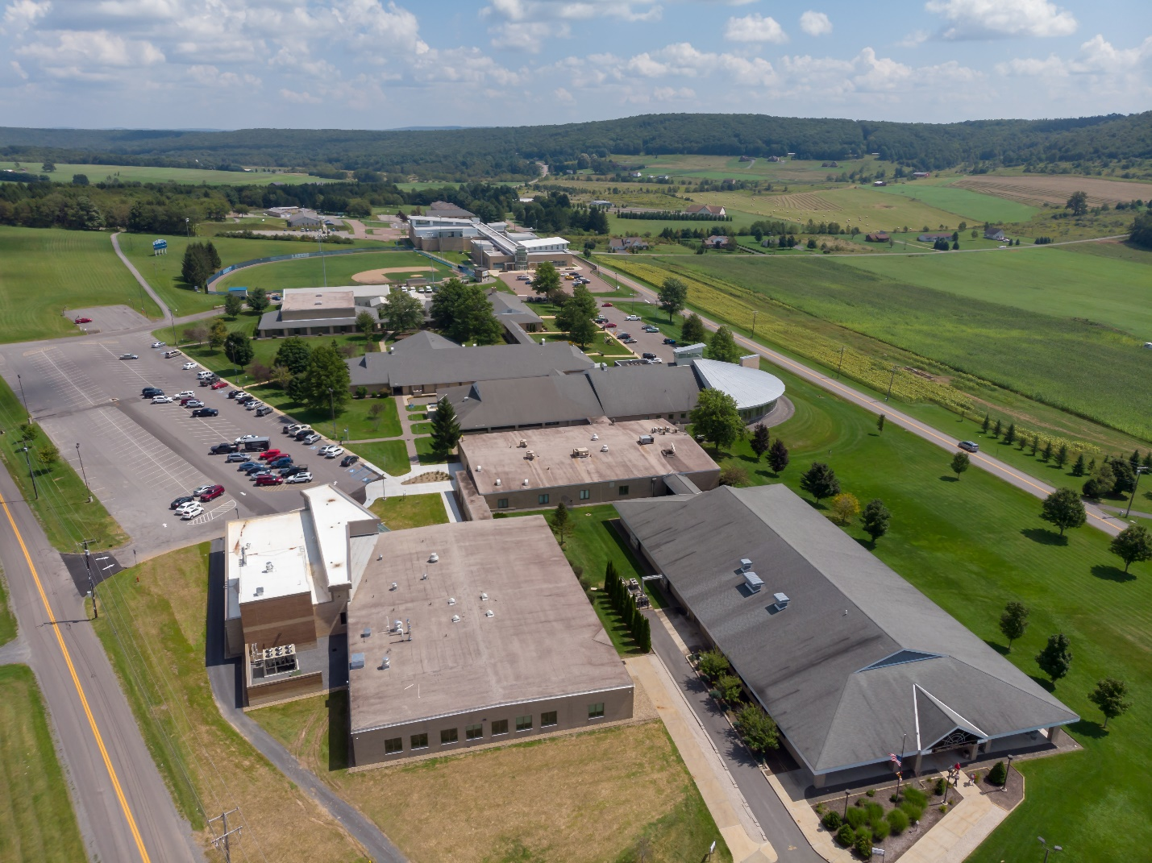

FACILITIES MASTER PLAN 2012-2022
Supplement Issued January 2016
Update Issued February 1, 2019

Update
February 1, 2020

TABLE OF CONTENTS

I. capital projects update 1

II. facilities renewal program 2

attachment

I. Capital Projects Update

Garrett College has three updates to our Capital Project list:
- Prioritize Building 600 ahead of Building 400
- Remove Parking Lot Expansions from the project list
- Defer Turf Fields, CAOS Addition, and Biomass Plant

Due to escalating maintenance issues with the sewer lines and HVAC systems in Building 400, along with the original justification for the renovation and expansion of the facility built in 1981, we are prioritizing this project ahead of the Building 600 renovation. The Part I will be developed this spring, and the Part II will be submitted in 2021.

A parking evaluation was done by Garrett County Department of Planning & Land Management during the summer of 2019 in conjunction with Garrett College’s Community Education and Performing Arts Center project. It was determined that no additional parking was needed on campus. The Parking Lot Expansion project will be removed from the Capital Projects list. Parking needs and inventory will continue to be monitored and reported annually in the MHEC CC Tables.

Garrett College continues to research three projects: the installation of turf fields, an addition for our Center for Adventure and Outdoor Studies facility, and a Biomass Plant. We are deferring each of these projects by a year. We are not requesting State or County funding for these projects at this time.

Proposed Projects | Fiscal Year | Estimated Project Cost ($000’s) | State Share ($000’s) | Local Share ($000’s)
- Building 800  Community Education & Performing Arts Center¹ | 19 | 18,470 | 14,685¹ | 3,785
- Building 400  Student Center | 23 | 4,260 | 2,130 | 2,130
- Building 600  Shaw Learning Center | 22 | 7,126 | 3,563 | 3,563
- Building 700 Administration and Student Services | 24 | 4,578 | 2,289 | 2,289
Parking Lot Expansions2 | 21 | 286 | - | 286
- Turf Fields² | 22 | 2,000 | - | 2,000
- Center for Adventure and Outdoor Studies Addition² | 23 | 1,273 | - | 1,273
- Biomass Plant² | 24 | 2,558 | - | 2,558

¹ This project is currently in the construction contractor bid stage. Funding is through the CCCIP (A&E) and the Governor’s Miscellaneous Fund (construction and equipment).
² State funding not being requested at this time.

II. Facilities Renewal Program

Garrett College has a 5-year Facilities Renewal Plan that is updated annually. We plan to fund most of these projects through the Facilities Renewal Grant. Garrett College is one of the colleges on the funding list for the Facilities Renewal Grant in FY21. See Attachment.

